Feedbacks/Suggestions

1. Hyperlinks on the webpage should be visible in Blue color once mousehover.

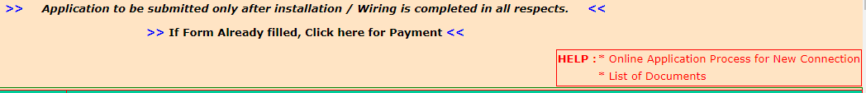

1. Scattered object should not be displayed on the page

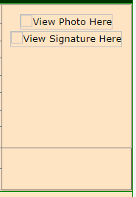

1. Middle Name of the Landlord is mandatory, which should not be



1. Address format should be consistent (Order of fields and Input type)

***Power Supply Address***



***Land Lord Address***

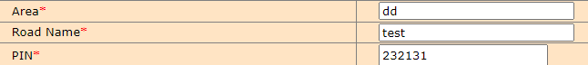

When Selected “No” radio button at “Whether power supply address is same as billing address *”

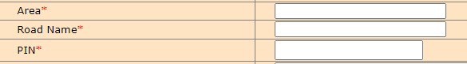

1. Label should be same across the page

Left aligned and highlighted



Center aligned and not highlighted



1. Not properly aligned

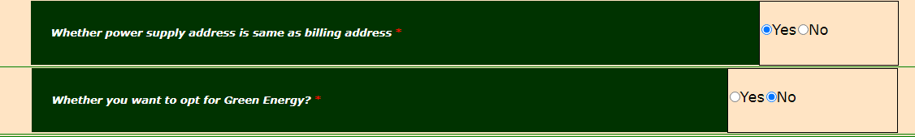

1. “Term and Conditions of Agreement” is no where is mentioned in the page (After clicking calculate load, Radio buttons “Yes” “No” greyed out and can’t be selected )

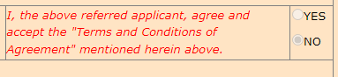

1. If file size is more than the expected size and user clicked upload photo button, user navigated to the top of the page. Warning message shown down and is in Blue color. (Allowed File size and file formats should be displayed while uploading the images/documents)



1. Spacing at the bottom of the page is not appropriate

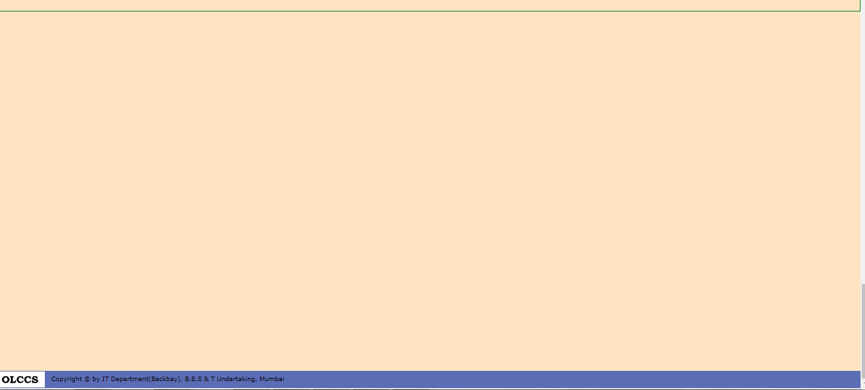

1. Suggestion : Any flash object in the page can be removed (Blue colored Arrows)

